Browser Object Model

The **Browser Object Model** (BOM) is used to interact with the browser. The default object of browser is window means you can call all the functions of window by specifying window or directly.

For example: window.alert(); or alert(); both will execute as same.

You can use a lot of properties (other objects) defined underneath the window object like document, history, screen, navigator, location, innerHeight, innerWidth.



**Window Object**: The window object represents a window in browser. An object of window is created automatically by the browser. Window is the object of browser **it is not the object of JavaScript**.

**Methods of Window Object:** alert (), confirm (), prompt (), open (), close () and setTimeout ();

**Document Object:** The document object represents the whole html document. When html document is loaded in the browser, it becomes a document object. It is the root element that represents the html document. It has properties and methods. By the help of document object, we can add dynamic content to our web page.As mentioned earlier, it is the object of window. It can be accessed either window.document or document

**Properties of Document:**

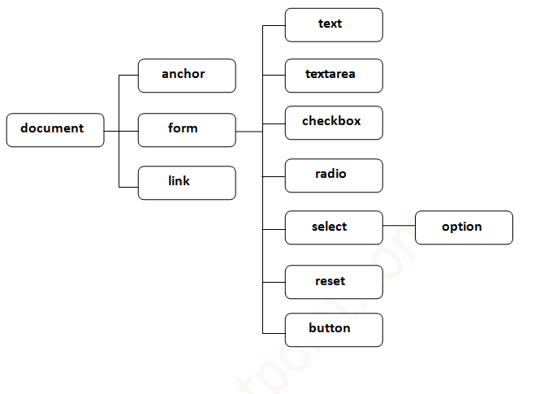

For example: We are using **document.formName.name.value** to get the value of name field.

**Methods of Document Object:** write(), writeln(), getElementById(), getElementsByName(), getElementByTagName() and getElementsByClassName().

**History Object:** The JavaScript history object represents an array of URLs visited by the user. By using this object, you can load previous, forward or any particular page. The history object is one of the window object property. It can be accessed either window.history or history.

**Property of History Object**: length

**Methods of History Object**: forward (), back () and go ().

**Navigator Object**: The JavaScript navigator object is used for browser detection. It can be used to get browser information such as appName, appCodeName, userAgent etc., The navigator object is one of the window property, so it can be accessed either window.navigator or navigator

**Property of Navigator Object**: appName, appVersion, appCodeName, cookieEnabled, userAgent, language, userLanguage, plugins, systemLanguage, mimeTypes[], platform and online.

**Methods of Navigator Object**: javaEnabled() and taintEnabled()

**Screen Object:** The JavaScript screen object holds information of browser screen. It can be used to display screen width, height, colorDepth, pixelDepth etc. The navigator object is the window property, so it can be accessed either window.screen or screen.

**Properties of Screen Object:** width, height, availWidth, availHeight, colorDepth and pixelDepth.

**Location Object:** The Location object represents the location (URL) of the object it is linked to. Both the Document and Window object have such a linked Location, accessible via Document.location and Window.location respectively.

**Properties of Location:** The Location object doesn't inherit any property, but implements those from URLUtils. Some of the properties are Location.href, Location.protocol, Location.host, Location.hostname, Location.port, Location.pathname, Location.search, Location.hash, Location.username, Location.password and Location.origin.

**Methods of Location**: The Location object doesn't inherit any method, but implements those from URLUtils. Some of methods are Location.assign(), Location.reload(), Location.replace() and Location.toString()